**Memory leaks and errors practice session**

**Typographical conventions**

**We use the following conventions in this guide:**

**emacs The name of a specific command or file**

**file You should replace file with a specific name**

**Exit abc Output that you see on the screen**

**valgrind command**

**valgrind --tool=memcheck –-leak-check=yes ./sample1**

**valgrind –-leak-check=yes ./sample1**

**1. Login into the Linux server with your login Ids**

**2. Create a new directory called mem_errors in your home directory <home>**

**mkdir mem_errors**

**3. Go inside the directory you have created in (2) /<home>/mem_errors**

**cd mem_errors**

**4. Copy the following files from the path as mentioned by the trainer:**

**a. sample1.c**

**b. sample2.c**

**c. sample3.c**

**d. sample4.c**

**e. sample5.c**

**5. Take a look at the example programs and observe if you can find any errors.**

**Compilation**

**6. Compile the files**

**gcc –o sample1 –g sample1.c**

**gcc –o sample2 –g sample2.c**

**gcc –o sample3 –g sample3.c**

**gcc –o sample4 –g sample4.c**

**gcc –o sample5 –g sample5.c**

**Execution**

**7. Execute the file sample1**

**valgrind –-leak-check=yes sample1**

**After quitting the program Valgrind displays a list of memory errors in the program. Analyze these errors.**

**8. Execute the file sample2**

**valgrind –-leak-check=yes ./sample2**

**After quitting the program Valgrind displays a list of memory errors in the program. Analyze these errors.**

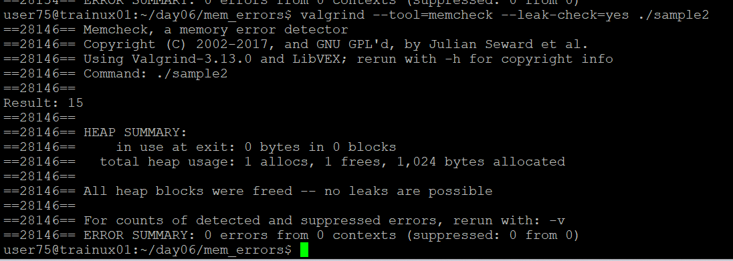

**9. Execute the file sample3**

**Valgrind –-leak-check=yes ./sample3**

**After quitting the program Valgrind displays a list of memory errors in the program. Analyze these errors.**

**10. Execute the file sample4**

**Valgrind –-leak-check=yes ./sample4**

**After quitting the program Valgrind displays a list of memory errors in the program. Analyze**

**11. Execute the file sample5**

**Valgrind –-leak-check=yes ./sample5**

**After quitting the program Valgrind displays a list of memory errors in the program. Analyze these errors.**

**12. Compile and execute the program in queue_linked_list_memory_leak**

**valgrind –leak-check=yes ./queue_llist**

**After quitting the program Valgrind displays a list of memory errors in the program. Analyze these errors.**